Pg.no 1

**CSE:-326 GROUP NO:-14 PROJECT:-24**

***APPENDIX 1***

***O*nline Tuck shop**

**End term report**

By

**Name of the Candidate Section Rollno:**

**1. Patani Umamaheswara Rao K19LC. 37**

**2. Thatavarthi Narendra Teja K19LC 42**

**3. Mullapudi Bharath. K19LC. 45**

LOVELY PROFESSIONAL UNIVERSITY



Department of Intelligent systems,

School of Computer Science and Engineering,

Lovely professional University, Jalandhar,

April-2020.

Pg.no 2

**APPENDIX 2**

**Student declaration**

This is to declare that this report has been written by me/us. No part of the report is copied from other sources. All information included from other sources have been duly acknowledged. I/We aver that if any part of the report is found to be copied, I/we are shall take full responsibility for it.

**1.P.umamheswararao. 11911596 37.**

**2.Thatavarthi Narendra Teja 11911625 42.**

**3.Mullapudi Bharath 11911640 45.**

Visakhapatnam

09-04-2020

Pg.no 3

**APPENDIX 3**

**TABLE OF CONTENTS**

**TITLE** PAGE NO.

1. Background and objectives 5
2. Description of the project 7
3. Description of workdivision 9
4. Implementation of scheduled work 10,11
5. Technologies used 12
6. SWOT analysis achieved in project 13

Pg.no 4

**APPENDIX 4**

**BONAFIDE CERTIFICATE**

**Certified that this project report “Online tuckshop" is the bonafide work of “P.Umamaheswara Rao,T.Narendra,M.Bharath,” who carried out the project work under my supervision.**

**NAME:-DR.Dhanpratap Singh**

**ID NO:-25706**

**SUBJECT:-CSE-326**

**<<Signature of the Supervisor>><<Name of supervisor>>**

**<<Academic Designation>> <<ID of Supervisor>>**

**<<Department of Supervisor>>**

Pg.no 5

Introduction

In this project , we have made the demo model of a webpage which can withstand with the present day working websites . The idea of this model is to make an easy user interface which can be accessed by everyone easily.

In brief, the page we have designed can be used for further linking with the database and can be used as an official website .In general, online tuckshop platforms are very busy as there is a lot of usage of those sites in everyday life.

So, this module gives us the information about how we can create a simple webpage with all the required components needed.

Our page works in a simple way , where the user gets logs into his account he will know the tuckshops in lpu and he can choose The items which shown there,submitting the details, the payment way is shown and after that the Items are booked successfully and the site returns to the homepage after the completion of this whole process.

Pg.no 6

The objective of the project assigned is to make a simple user interface for Online tuckshop . In order to that, we have made an interface where the users can easily understand the modules in the site and can book their Items easily .

The interface we have designed will be official enough with all the basic required modules in that like home module and many paths like choosing destinations and journey path etc where the process is not so complex in developing the interface but also for the users to use the webpage. In general, the work of any online platform is to decrease the efforts of the customer , as in traditional manner the efforts might increase and also time consuming . This time consumption and human efforts can be decreased by these online platforms .In order to achieve that, these interfaces have been developed.

Pg.no 7

**DESCRIPTION OF THE PROJECT**

Our project consists of the following modules :

**->** Login module

**->** Home module

**->** submission module

**Login module :-**

After opening the page ,first we witness the login module/button ,with which the user can log in by filling the required details like his/her name and mobile number etc ,so that it can be a confirmation that it is being used by the right person. After filling all the required details and entering the password sent to your mobile, you will be redirected to the next page

Pg.no 8

**Home module :**

In the home page, the required details of login id and password .after login to the page we will came to know the shops in lpu and items which are available there.

After filling all the required details we can submit the details and then a new page will be opened which helps us in paying ths. There after ,by clicking the submit button ,we wil be redirected to the next page.

**Submit buttons:**

These submit buttons are used in redirecting to the next pages.

**Contact Us module:**

This displays the information of the website so that the users can contact the webpage in need of any information like the journey details.

**About us :**

This shows the details of the webpage creators and the work of the website

Pg.no 9

**Description of work division in terms of roles** :

The project has been designed by three members ,in which the project synopsis has been made by the three of us ,where the work has been equally divided among us and in the website interface creation, the login module has designed by Narendra And bharath and the homepage has been done by Umamaheswararao

first module – by Mullapudi bharath

Main Page –by T.Narendra Teja

Home page –by P.Umamaheswararao

The work has been divided into three categories and have been performed by all the three members of our group .

Pg.no 10

Implementation of work project

**STEP :- 1**

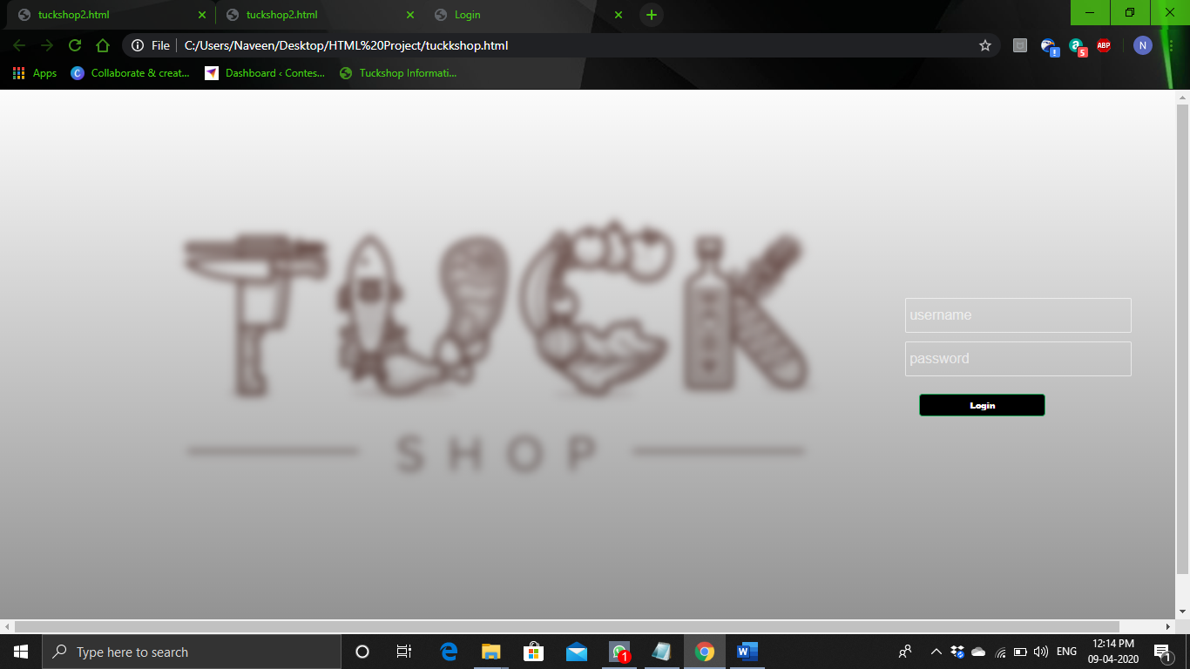

**IN THIS PAGE WE HAVE TO ENTER THE USERNAME AND PASSWORD AND THEN ENTER LOGIN WE CAN GO FOR NEXT PAGE….**

[For :- Demo (enter anything)]

Pg.no 11

**STEP:-2**

**FIRST SHOP**

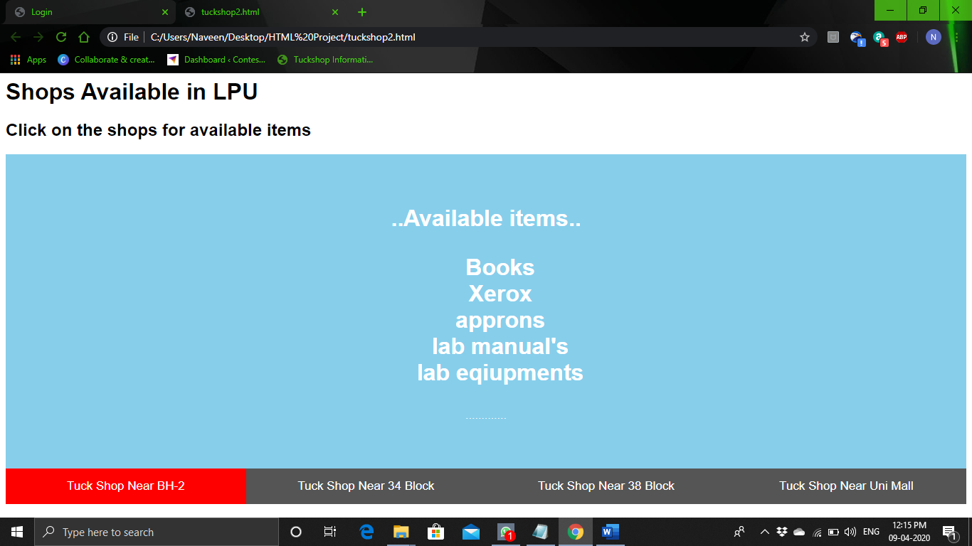

**SECOND SHOP**

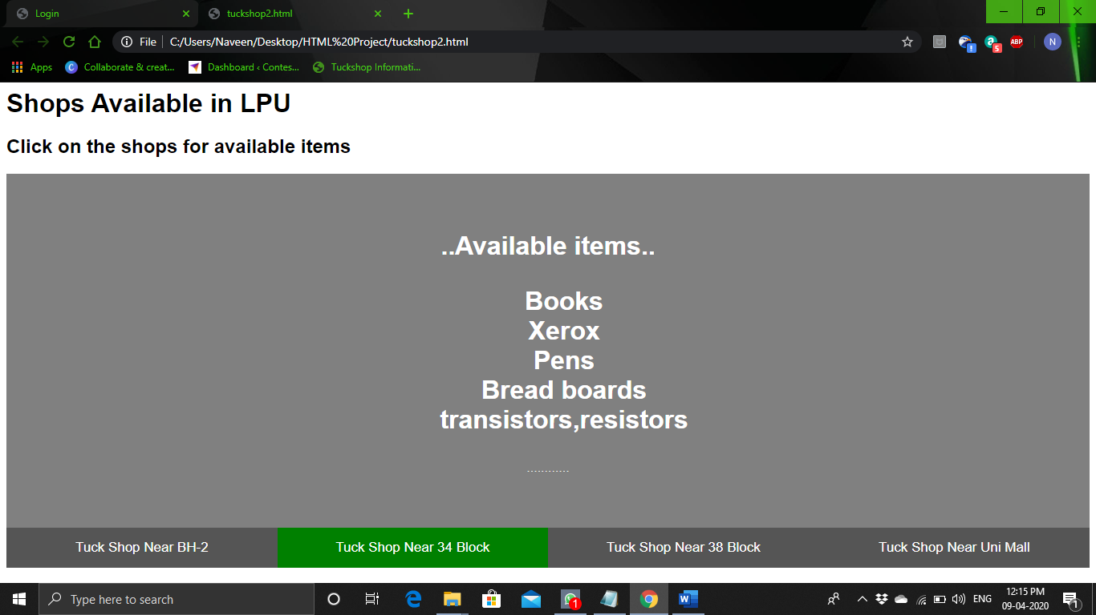

**PAGE-12**

**THIRD SHOP**

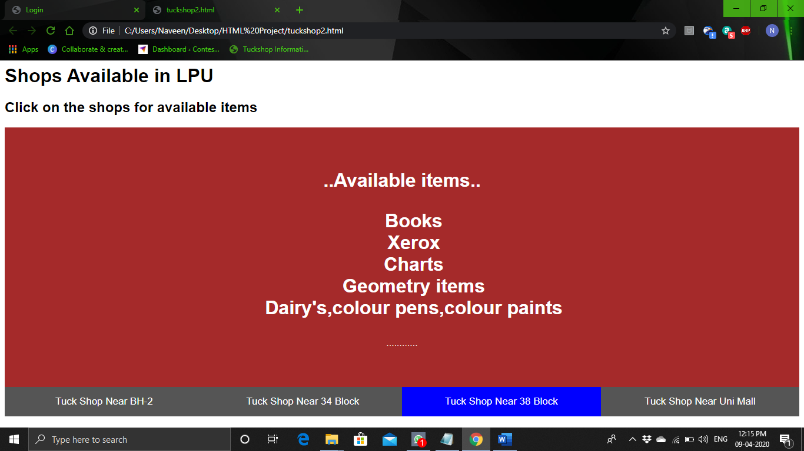

**FOURTH SHOP**

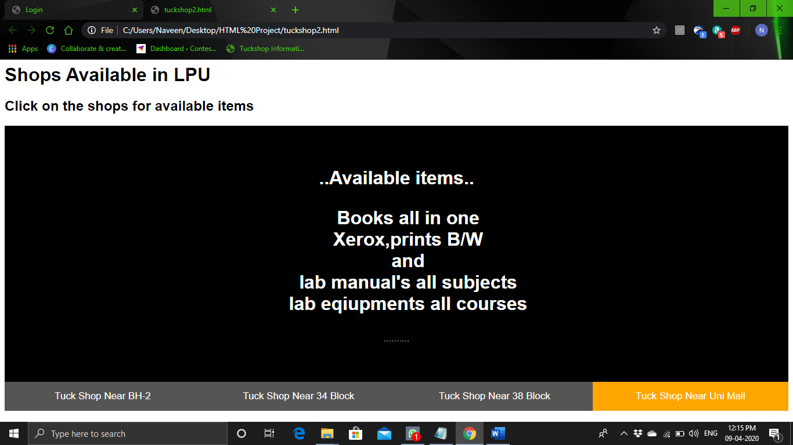

Pg.no 13

**Technologies and framework to be used**

The framework and technology used in this project is html,css,javascript.

**SWOT analysis of the project :-**

This simple webpage interface is easily accessible and understandable. If this is implemented completely with the connection of a database, this can compete with the webpages in the present world and can be useful to the people ,since there is lot of need of such websites for the people for simplification of their life.

**PROJECT DONE BY :-**

**T. Narendra Teja [11911625][42]**

**P.UmamaheshwaraRao [11911596][37]**

**M .Bharath [11911640][45]**

THANK YOU……